Driving Directions

District Office
1351 Washington Street
Watertown, NY 13601

Phone Number: 315-785-3700
Fax Number: 315-785-6855
Office Hours: Monday - Friday: 8:00 AM - 4:00 PM
https://www.watertowncsd.org/site/default.aspx?PageType=3&ModuleInstanceID=2954&ViewID=503a3e79-9340-40fd-8d85-f3b476c2baf0&RenderLoc=0&FlexDataID=6355&PageID=2765

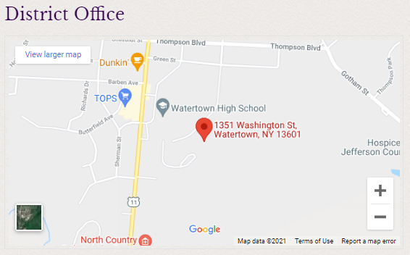

Central Registration
1351 Washington Street - H.T. Wiley Intermediate School
Watertown, New York 13601
https://www.watertowncsd.org/site/default.aspx?PageType=3&ModuleInstanceID=2954&ViewID=503a3e79-9340-40fd-8d85-f3b476c2baf0&RenderLoc=0&FlexDataID=458&PageID=2765

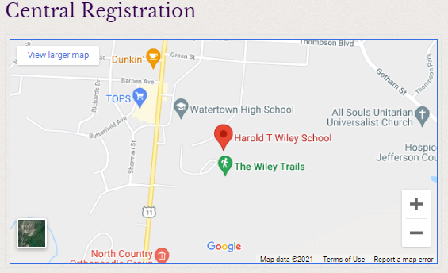
Watertown High School
1335 Washington Street
Watertown, NY 13601
https://www.watertowncsd.org/site/default.aspx?PageType=3&ModuleInstanceID=2954&ViewID=503a3e79-9340-40fd-8d85-f3b476c2baf0&RenderLoc=0&FlexDataID=457&PageID=2765

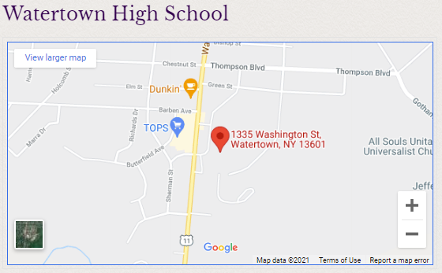

Case Middle School
1237 Washington Street
Watertown, NY 13601

https://www.watertowncsd.org/site/default.aspx?PageType=3&ModuleInstanceID=2954&ViewID=503a3e79-9340-40fd-8d85-f3b476c2baf0&RenderLoc=0&FlexDataID=462&PageID=2765

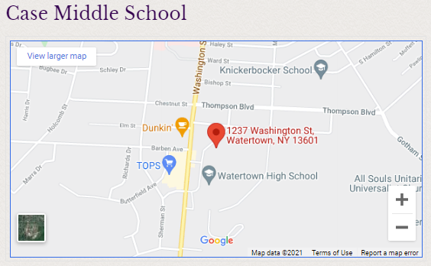

H. T. Wiley Intermediate School
1351 Washington Street
Watertown, NY 13601

https://www.watertowncsd.org/site/default.aspx?PageType=3&ModuleInstanceID=2954&ViewID=503a3e79-9340-40fd-8d85-f3b476c2baf0&RenderLoc=0&FlexDataID=463&PageID=2765

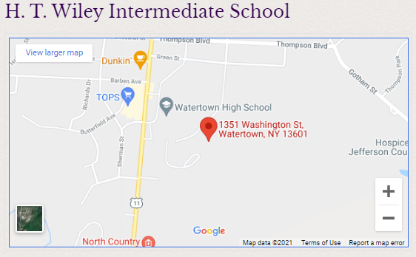

Knickerbocker Elementary
739 Knickerbocker Drive
Watertown, NY 13601

https://www.watertowncsd.org/site/default.aspx?PageType=3&ModuleInstanceID=2954&ViewID=503a3e79-9340-40fd-8d85-f3b476c2baf0&RenderLoc=0&FlexDataID=464&PageID=2765

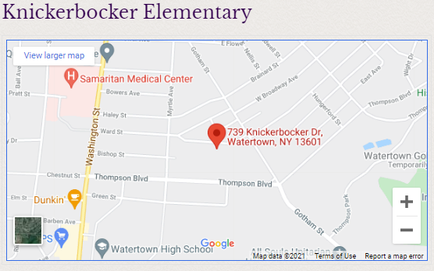

North Elementary School
171 East Hoard Street
Watertown, NY 13601

https://www.watertowncsd.org/site/default.aspx?PageType=3&ModuleInstanceID=2954&ViewID=503a3e79-9340-40fd-8d85-f3b476c2baf0&RenderLoc=0&FlexDataID=465&PageID=2765

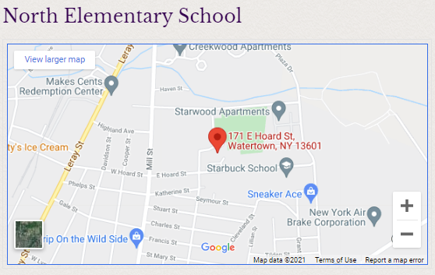

Ohio Elementary School
1537 Ohio Street
Watertown, NY 13601

https://www.watertowncsd.org/site/default.aspx?PageType=3&ModuleInstanceID=2954&ViewID=503a3e79-9340-40fd-8d85-f3b476c2baf0&RenderLoc=0&FlexDataID=466&PageID=2765

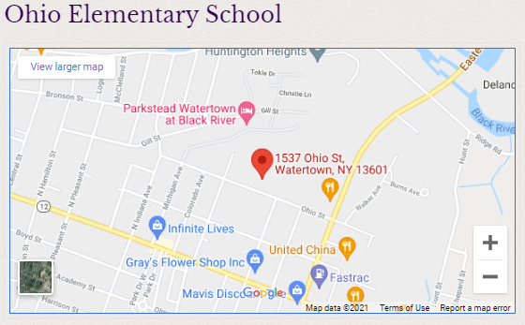

Sherman Elementary School
836 Sherman Street
Watertown, NY 13601

https://www.watertowncsd.org/site/default.aspx?PageType=3&ModuleInstanceID=2954&ViewID=503a3e79-9340-40fd-8d85-f3b476c2baf0&RenderLoc=0&FlexDataID=467&PageID=2765

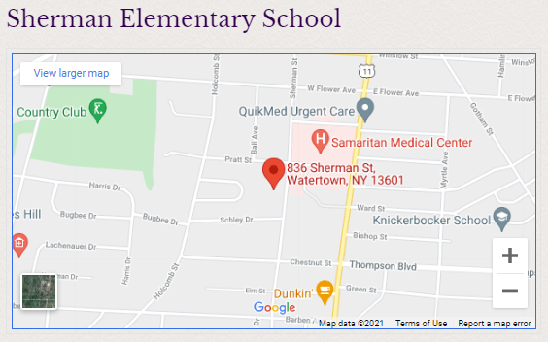

Starbuck Elementary
430 East Hoard Street
Watertown, NY 13601

https://www.watertowncsd.org/site/default.aspx?PageType=3&ModuleInstanceID=2954&ViewID=503a3e79-9340-40fd-8d85-f3b476c2baf0&RenderLoc=0&FlexDataID=468&PageID=2765

